Mario Donnadieu A00226091

Julio Almada A00226046

**Electrode Positioning for Three Hand-Wrist Movements**

* **First Movement: Closing Hand.**

The negative electrode is placed between the finger flexors and wrist flexors turning to the medial epicondyle which is marked with the X on the second image, and the positive electrode is placed over the tendinous portion of the forearm.

* Muscles Used:

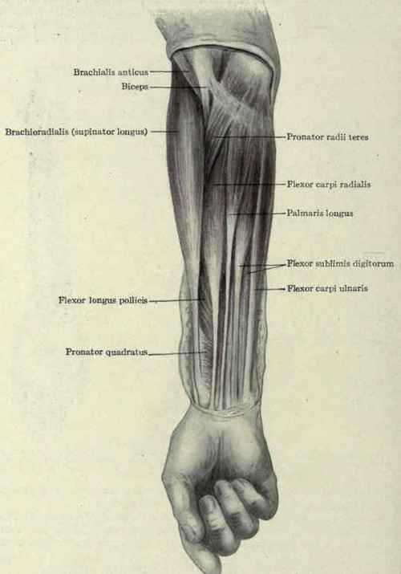

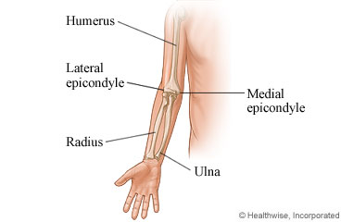

* Movement done for the therapy:

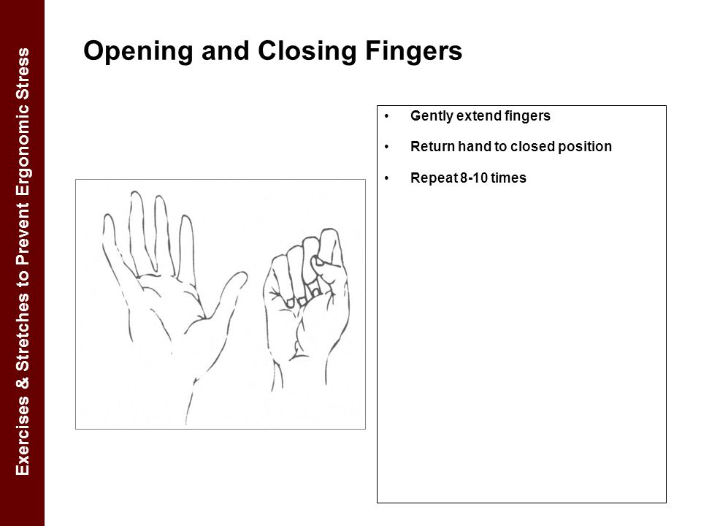

* Electrode positioning:

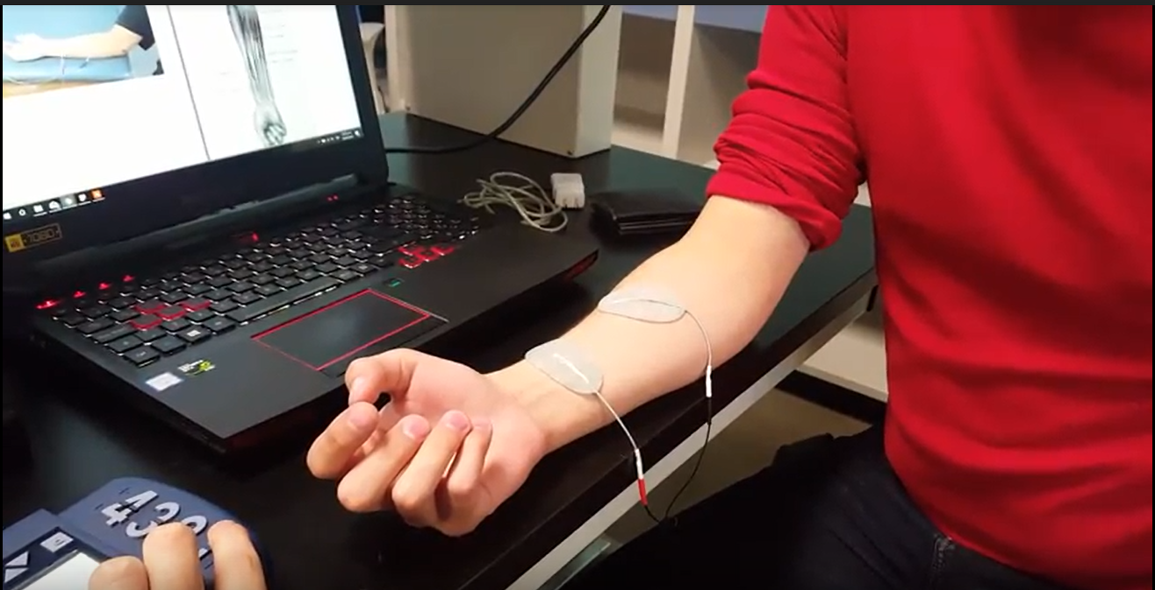

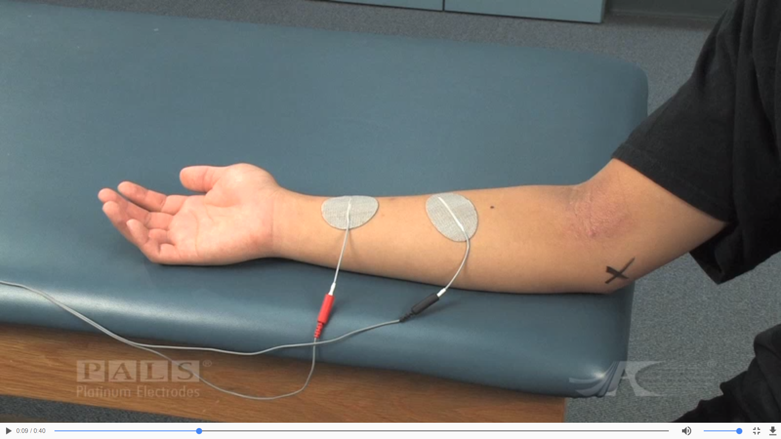

* Result:

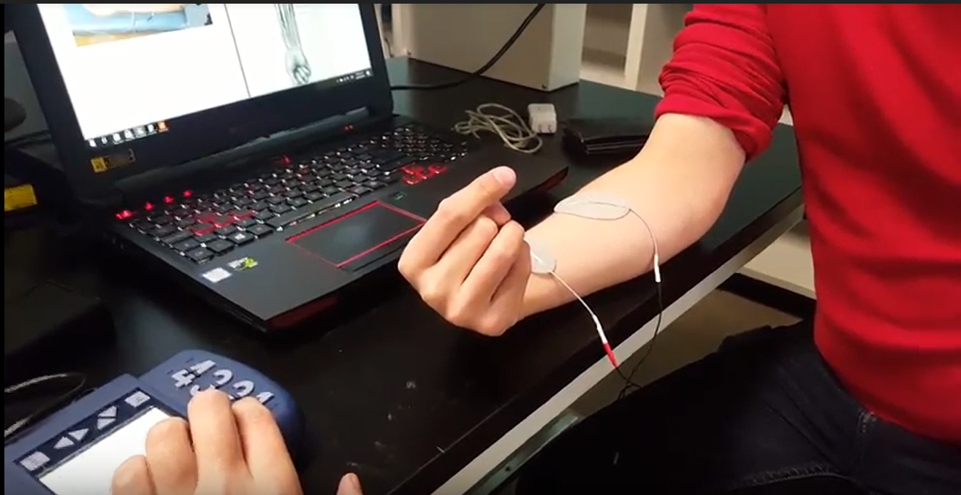

* **Second Movement:Wrist Extension**

The following image describes the wrist extension movement.

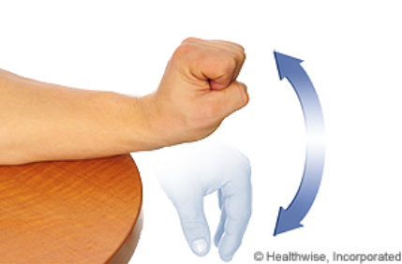

To achieve this movement, the positive electrode is located over the tendinous area of the forearm. And the negative one is located distal of the lateral condyle.

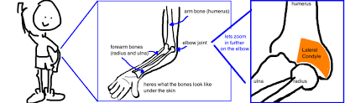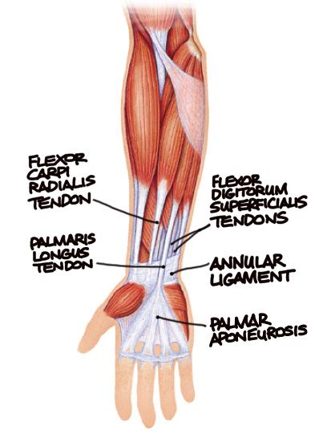

Physically, the location of the electrodes can be seen in the next two images. The lateral condyle is marked with an x.

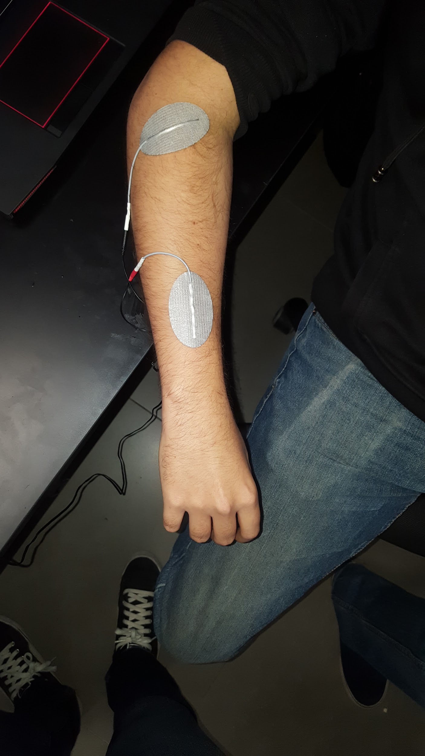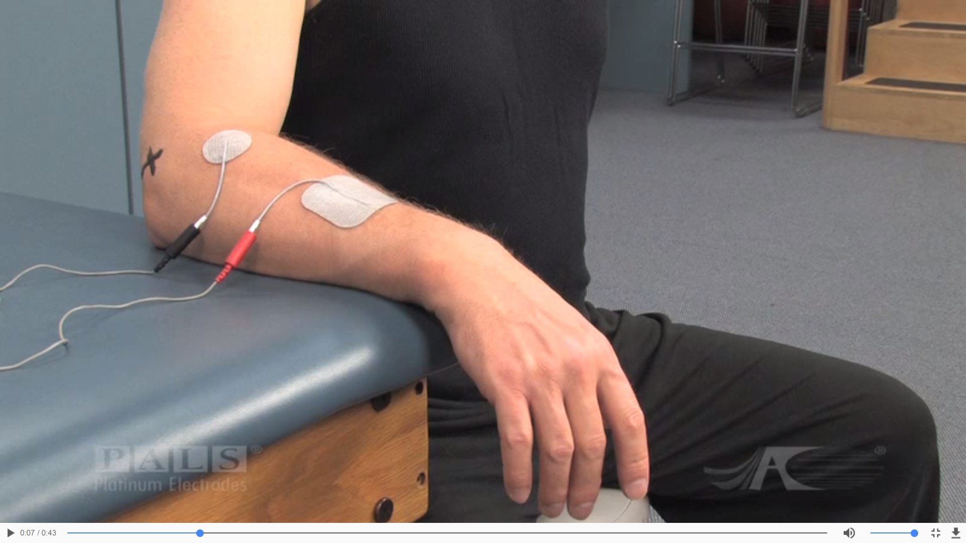

A current of 35 Hz of frequency, a pulse width of 300 microseconds and an amperage depending on the test subject was applied through the electrodes. The results can be seen in the following figures.

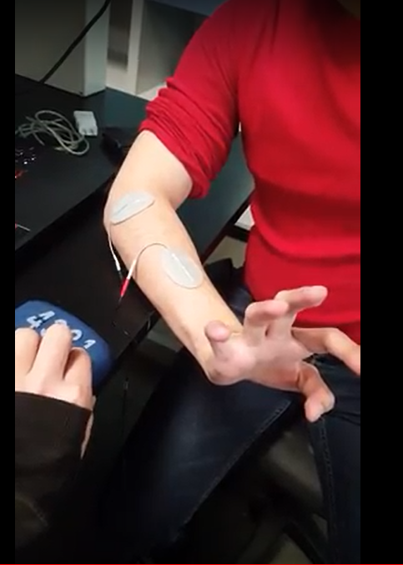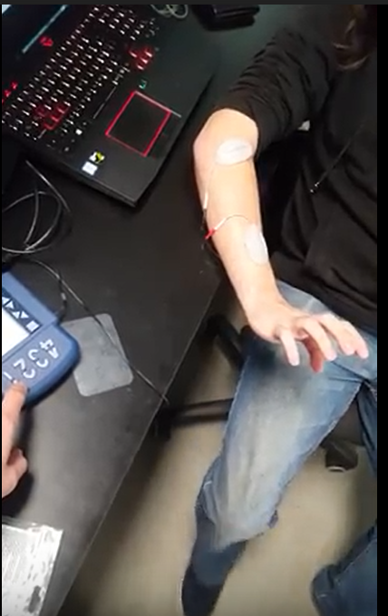

* **Third Movement: Radial Deviation:**

The following image describes the radial deviation movement.

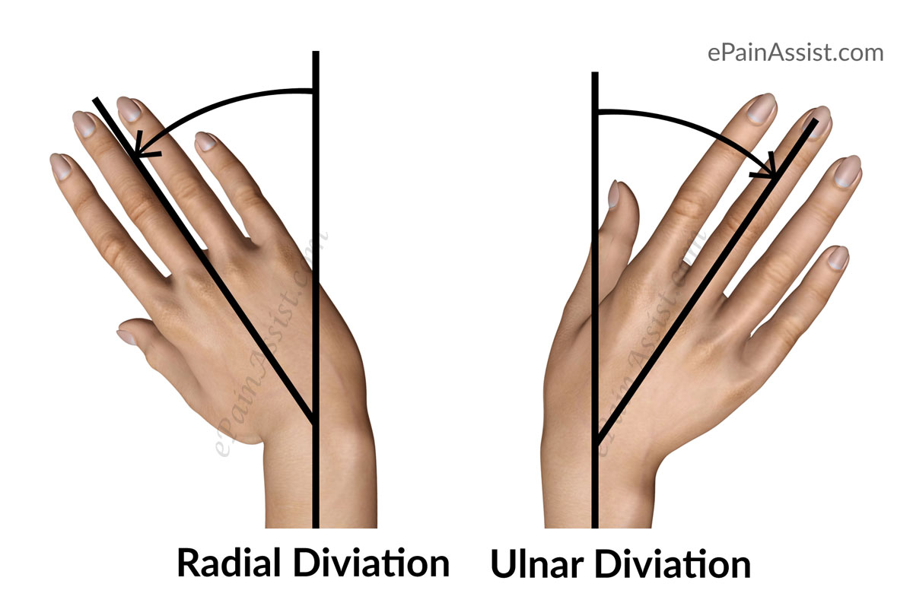

To achieve this movement, the positive electrode is located over the tendinous area of the forearm. And the negative one is located on the tendinous area.

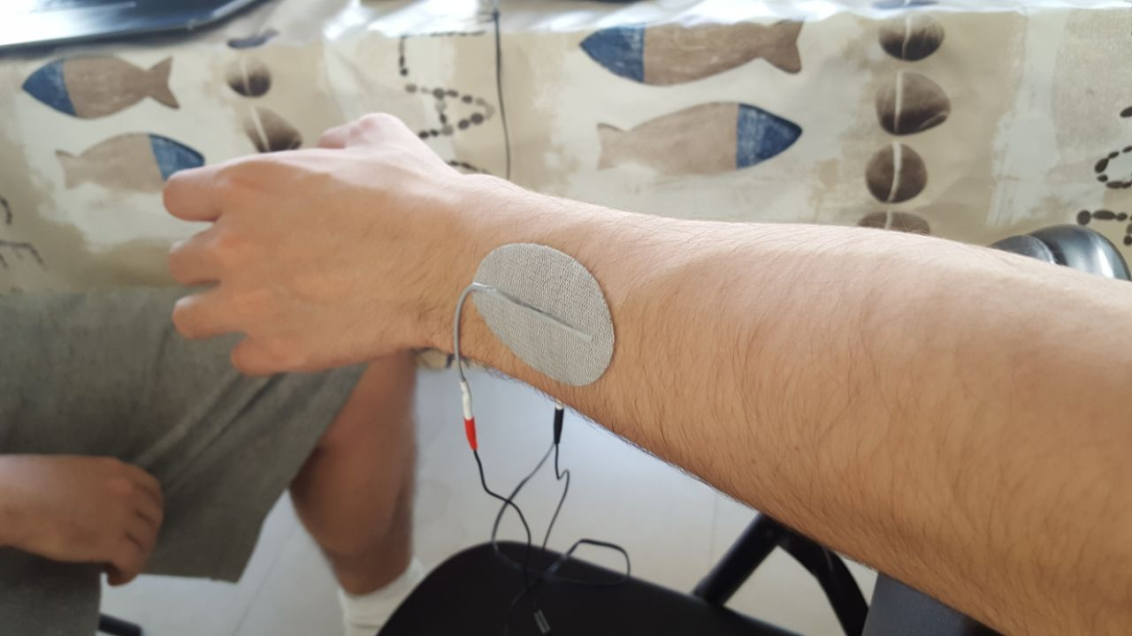

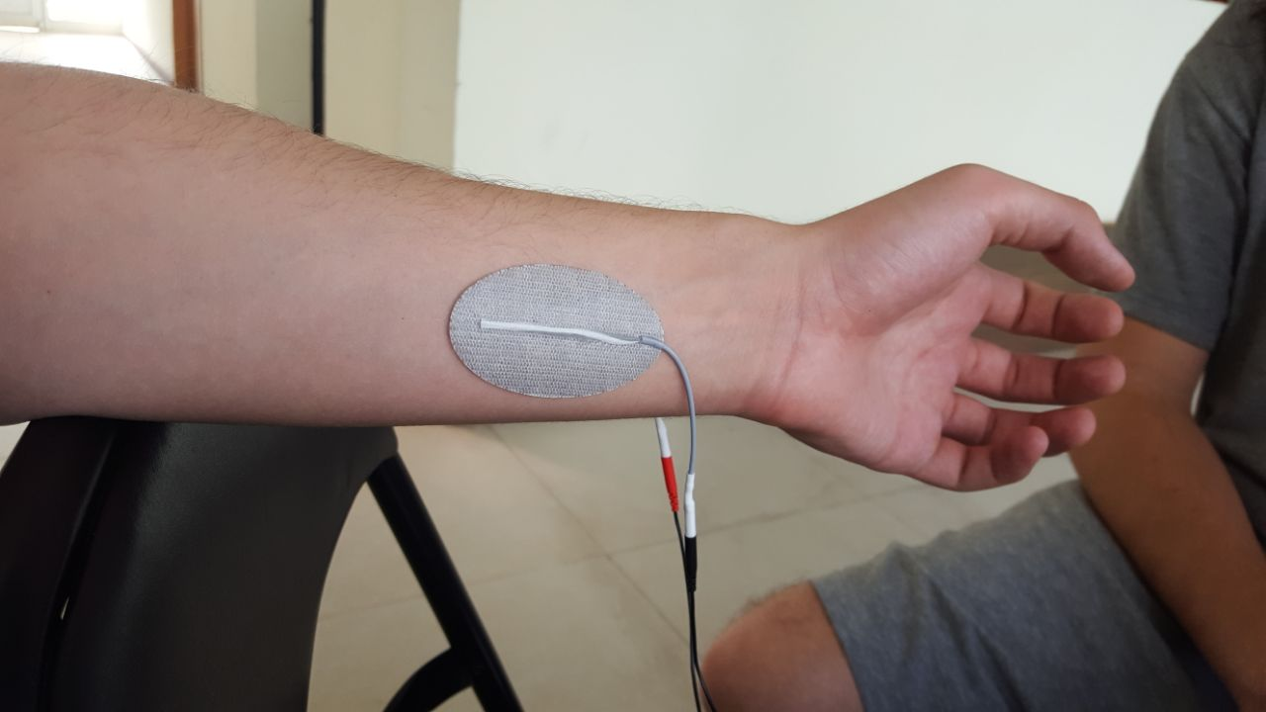

Before and after current is applied to the arm.

